Model

* More abstract than code
* Often non-code representation of a function which we use to help us figure out how to code the function

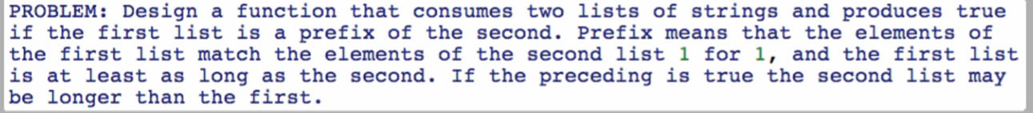

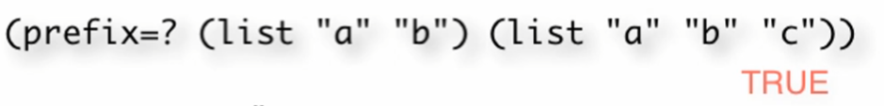

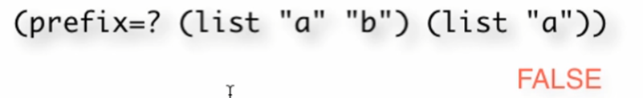

Data definition:

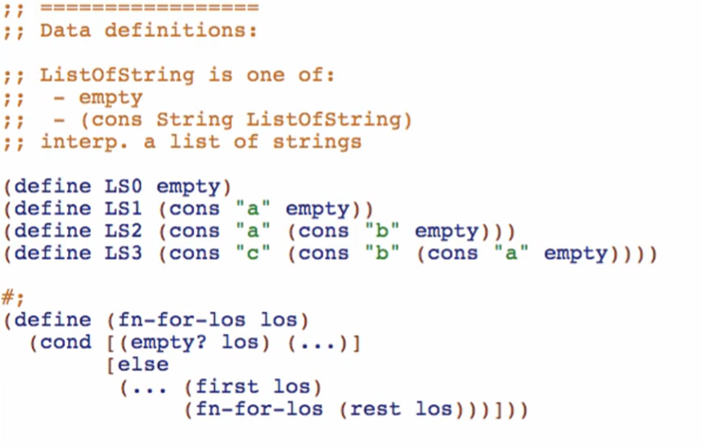

Function definition:

**Signature, purpose and stub**

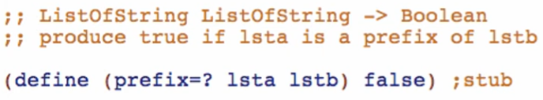

**Examples**

For making examples, we are introducing **Cross Product of Type Comments**

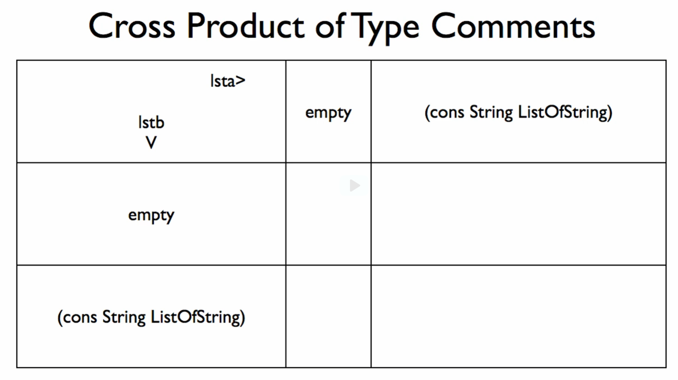

* Use this when you have a function consuming TWO ONE-OF DATA; the two arguments DON’T have to be identical, but both must be one-of.

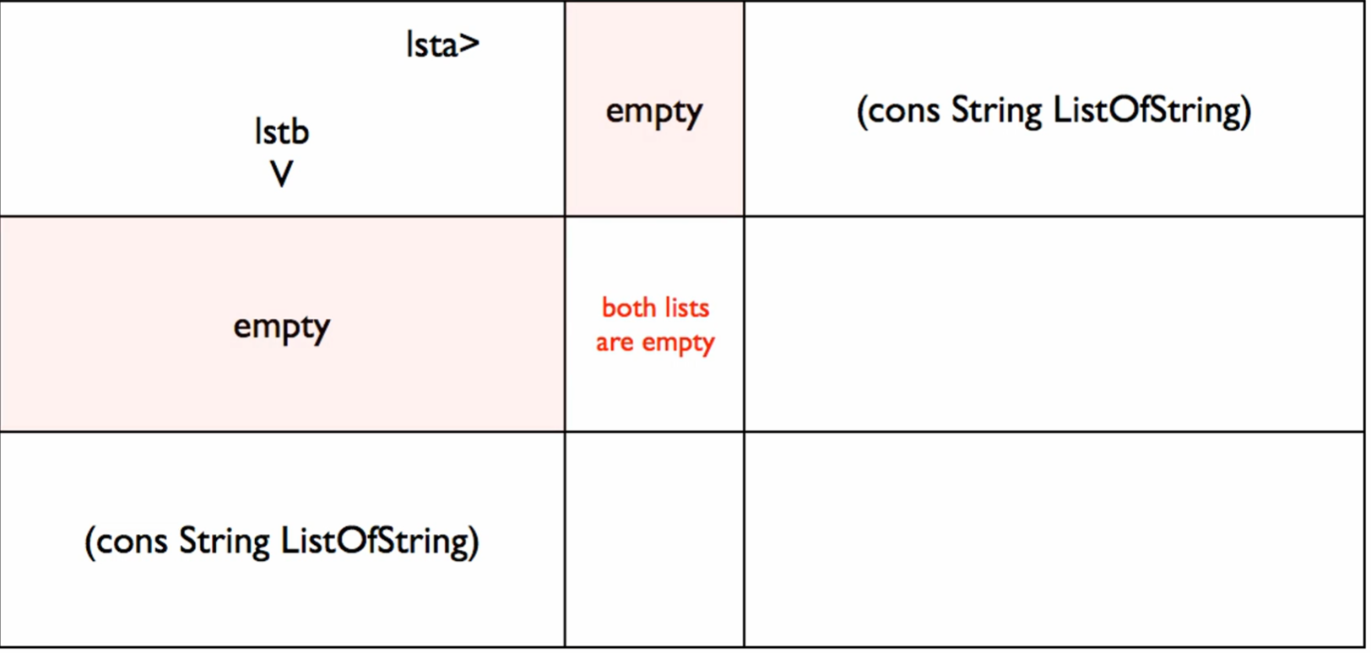

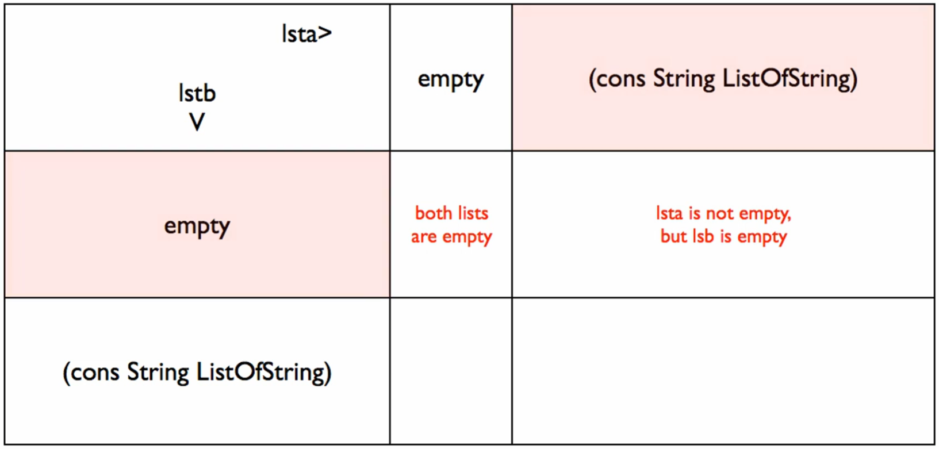

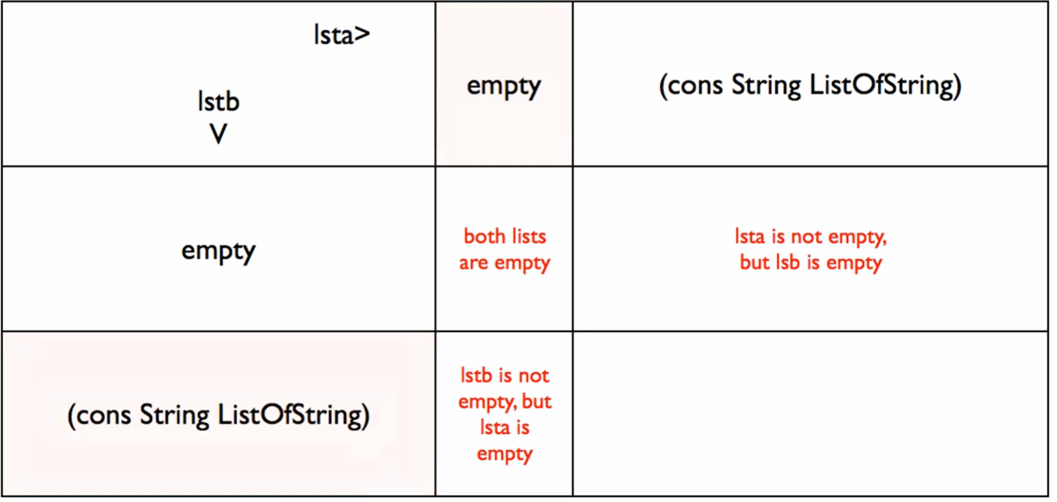

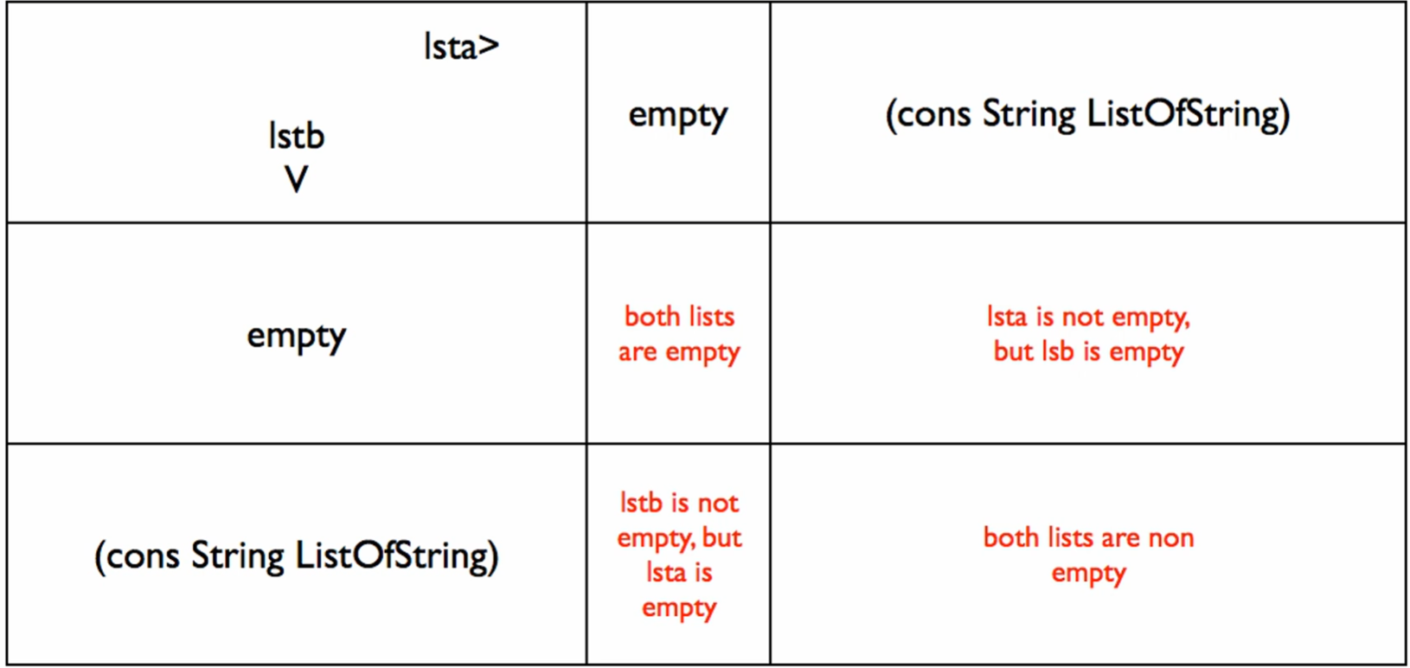

* You need at least 4 cases with these cross products!

Doing the check-expects

At least 4: 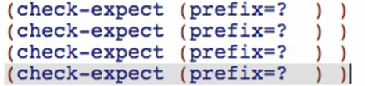

1st cross product (both empty)

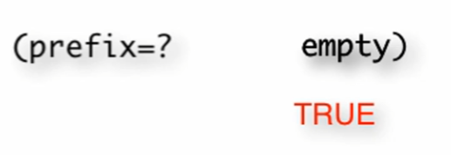



2nd cross product (lsta is not empty, but lstb is empty)

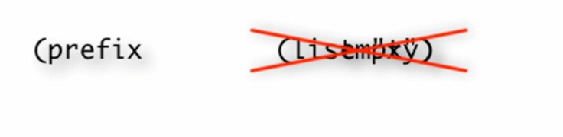



3rd cross product (lsta is empty, but lstb is not empty)

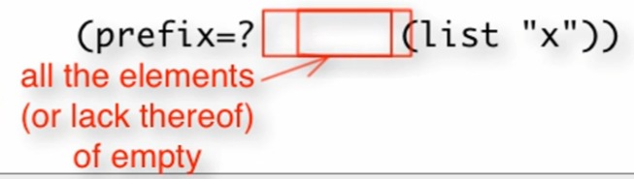



4th cross product (lsta is not empty, lstb is not empty)

Base cases:





At least 2 long:

